Wild Ones Louisville: Lawns-to-Natives Reimbursement Program: Description and Instructions- 2026-2027
Wild Ones Louisville (the Louisville Chapter of the national organization Wild Ones) is offering a cost-share reimbursement program designed for replacing lawn with native plants in residential yards. Homeowners in Jefferson County are encouraged to apply. The goal of the program is to encourage lawn replacement in residential yards with plants native to Kentucky and nearby areas by reducing financial barriers. A reimbursement check will be mailed to your address once the reimbursement form, proof of payment, and photo documentation of your project are received. Read the Managed Natural Landscapes ordinance before you begin this project. https://louisville.wildones.org/louisvilles-weed-ordinance/
WE PROVIDE A CHECK LIST OF STEPS FOR YOU AT THE END OF THESE MORE DETAILED INSTRUCTIONS AND EXPLANATIONS.
Submit a ‘before’ photo of the lawn area to be replaced. Submit photos of the prepared bed showing the grass covered with mulch (if using cardboard or plastic or landscape fabric to smother the grass), or the dead grass if using herbicide. These photos must include a tape measure showing the length and width of the bed. Submit a photo of the newly planted bed and photos of purchase receipts. The minimum area of lawn that will be considered is 100 square feet. There is no maximum area, but we will only cover the costs for plants up to $200 as described below. We will NOT pay for the planting of “hell strips”- grassy strips between street and sidewalk. We will NOT pay for plants planted within 5 feet of a sidewalk or the street if there is no sidewalk, or within 5 feet of the property line with your neighbors (unless you have a 4-foot opaque fence), so that you stay in compliance with the Natural and Managed Landscapes Ordinance rules.
LAWN AREA REMOVAL CATEGORIES
Wild Ones Louisville (WOL) will reimburse 80% of total plant costs in two categories of former lawn area, as follows:
- A maximum of $100 for at least 100 square feet (sq. ft.) of lawn removed (10x10 ft or other equivalent dimensions totaling 100 sq. ft.)
- A maximum of $200 for at least a total of 200 sq. ft. of lawn removed (20 x10 ft or other equivalent dimensions totaling 200 sq. ft.). This can be two separate lawn areas totaling at least 200 sq. ft.
AMOUNT REIMBURSED
If you spend $125 or more on plants for the 100 sq. ft. bed, for example, you would get a maximum reimbursement of $100. If you spend $250 or more in the 200 sq ft category, you will get the maximum reimbursement of $200.
METHODS FOR KILLING GRASS
You can search online for different methods. The most common methods include: digging, solarization with plastic or landscape cloth, smothering with cardboard, and herbicide applications. We encourage you to use the non-herbicidal methods. If you use cardboard boxes, choose ones that are as plain as possible and remove tape from them. If you use the plastic or landscape cloth solarization method, be sure to remove them in late winter before planting.
Here are two weblinks that show you these methods: https://www.youtube.com/watch?v=M4abxjpmrjI
https://www.bobvila.com/articles/how-to-kill-grass/

WHICH PLANTS QUALIFY?
Plants may include only trees, shrubs, and herbaceous (non-woody) native plants, and must be straight native species rather than named horticultural cultivars of native species. You can check if your plant species is native to Kentucky or nearby areas by going to this website: https://www.kynativeplants.com/native-plant-finder Or you may find other websites you trust.
Purchase of cultivars of native plants (sometimes called Nativars) will not be reimbursed. Cultivars (Nativars) are clones selected for certain traits and reproduced from the original native plant by the horticulture industry. You can recognize cultivars because the plant’s Latin name is followed by a cultivar name in single apostrophes and is written on the pot label. For example, the straight species of Purple Coneflower is Echinacea purpurea. But a cultivar would be labeled Echinacea purpurea ‘Bravado’ or simply Echinacea ‘Bravado’. Bravado is the cultivar name. There are many different cultivars of Purple coneflower, such as ‘Magnus’, ‘Hot Papaya’, etc.
We will be encouraging you to purchase Kentucky native plants from local vendors who sell and some who even grow them. They should be prepared to tell you whether the plant you want is a straight Kentucky native species or not. We highly recommend that you do NOT purchase plants in large pots, which is costly. Instead purchase small potted plants (2 to 4-inch) or plant plugs. That way you can cover more space for less money and not put your eggs all in one basket by using just a few costly plants in large pots- which if they died would leave you with little to show for your time, money and effort.
If you would like to know the reasons why we are restricting reimbursement to straight species, please read the explanation that our Wild Ones National Organization provides: https://wildones.org/resources/guidelines-for-selecting-native-plants/
PHOTO DOCUMENTATION
For photo documentation of the amount of lawn removed, take a “before” photo of the lawn, a photo showing the method of removal, and then an “after” photo of the same spot with the lawn removed. Then take a photo of the planted bed. Include tape measures in these photos so we can judge the size. (more details below in checklist)
You will save and submit these photos as jpg or jpeg files with the completed reimbursement form.
Name these files as follows:
First Name-Last Name-Before
First Name-Last Name-During
First Name-Last Name-After
First Name-Last Name-Planted

PROOF OF PAYMENT
Proof of payment is authorized in two parts.
- An itemized invoice or itemized receipt(s) from the vendor. The items are the plant species names and number of plants for each species. You may have to request an itemized receipt.
Take a photo(s) of the invoice/itemized receipts and submit as jpg or jpeg files. Please be sure they are legible.
Label file as follows: First Name-Last Name-Receipt 1 (Receipt 2 etc. if there were more)

- a cancelled check or credit/debit card statement. Cash payments will not be accepted. Proof of payment documents must be in the name of the individual that was submitted on the reimbursement form.
Proof of payment for plants should be dated from September 15, 2026 to May 31, 2027.

SUBMISSION OF FORMS, PHOTOS AND RECEIPTS
We will be having a ROLLING DEADLINE. People may submit their documentation and reimbursement application starting on October 1, 2026. This start date would reflect people having had time to kill lawn in August and September and plant in early fall, if people desire. But the absolute deadline to submit documentation will be June 1, 2027. This should allow people time to kill lawn in either late summer-early fall, overwinter, OR early in spring with time to plant by May.
HOWEVER, reimbursements will be approved as they are received until funding is exhausted.
Wild Ones Louisville will be setting aside $2,000 for this program. This means that we could be reimbursing a maximum of 20 applicants if all were 100 sq ft lawn replacements. So, if obtaining plant reimbursement is very important to you before starting, PLEASE EMAIL US TO DETERMINE IF OUR FUNDS ARE EXHAUSTED FOR THE PERIOD. Our email is wild.ones.louisville@gmail.com
THE REIMBURSEMENT APPLICATION FORM IS A GOOGLE FORM, WHICH WE CAN ACCESS UPON YOUR COMPLETING IT.
HOWEVER, SEND THE PHOTOS OF THE YARD AND YOUR RECEIPTS TO wild.ones.louisville@gmail.com In the email subject header, please enter YOUR LAST NAME and Native Plant Reimbursement. Depending on jpg size, you may have to send them all in 2 or 3 separate emails.
HERE IS THE LINK TO THE GOOGLE FORM: https://forms.gle/J2jxKDHwgzAfwwrh9
FOLLOW-UP. Wild Ones Louisville Board Members will want to visit your yard and take photos of the area you planted in later months to share and celebrate your success! By participating in this cost-share program, you agree to allow us to take these photos IN YOUR PRESENCE.

NATIVE PLANT VENDORS LIST
Vendors in the Louisville area include but are not limited to: (Let them know you want to purchase straight species that are Kentucky natives)
Above the Dirt Garden Shop https://www.abovethedirtgardenshop.com/
Dropseed Nursery https://www.dropseednursery.com/
Idlewild Butterfly Farm https://idlewildbutterflyfarm.com/
Ironweed Native Plant Nursery https://www.ironweednursery.com/aboutus.asp
Louisville Native Plant Nursery https://louisvillenative.com/
Peacock Valley Nursery and Farm https://www.peacockvalleynursery.com/
Roundstone Native Seeds: https://roundstoneseed.com/ (you will want small packets). Make sure the final photo shows these seedlings in the planted bed.
WONDERING WHICH REGIONAL NATIVE PLANTS WE RECOMMEND FOR A STARTER GARDEN? You can download this list for sun vs shade plants from this our website here as a docx or pdf file:
https://docs.google.com/document/d/1yHOUiiNvNx7b7tasAOX8_eWSKFiHB2fh/edit

LINK TO REIMBURSEMENT APPLICATION AS A GOOGLE FORM
https://forms.gle/jsy8o3f1zbrJa27i8

CHECKLIST OF STEPS TO FOLLOW WHILE IMPLEMENTING THE PROJECT AND FOR SUBMISSION OF APPLICATION

- Take an overview photo of your planned garden area before grass is removed. Name the photo as described above.

- Take photo of your bed preparation/grass removal method. Name the photo as described above. Example below.
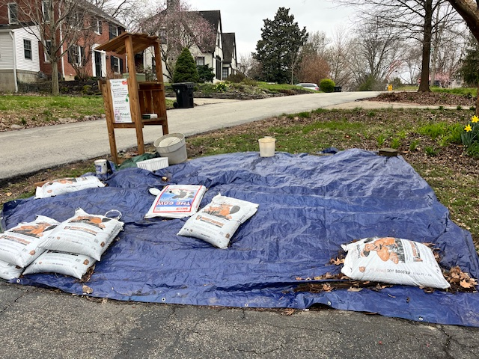

- Take photos after grass is removed that includes tape measures at a distance and close up so we can read the numbers. These measurements must include the length and width of the bed. See below.

- Calculate area of grass removed. We will double check that after reading photos with tape measures. Name the photo as described above.
See example photos below taken after grass was removed. Left shows total distance. Right shows a closeup that we can read.

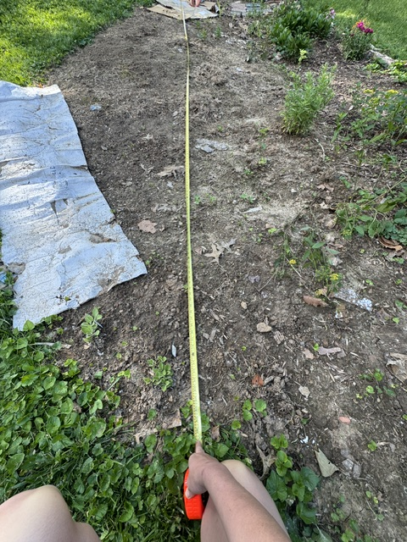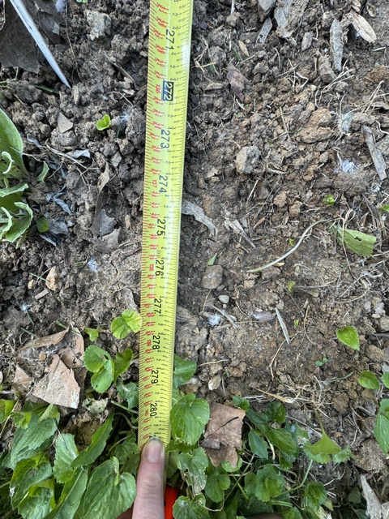

- Take photo of your new garden with native plants planted. Name the photo as described above.
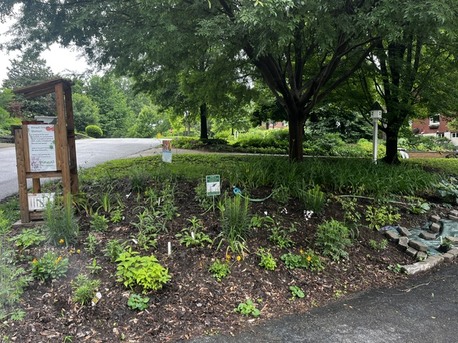
- Take photos of your itemized receipt(s), also showing that they are straight natives (if vendor writes that on the receipt that will be enough). Make sure the numbers and names are legible. If you purchased from one of our pre-approved vendors, we know they are straight natives. Name the photo as described above.

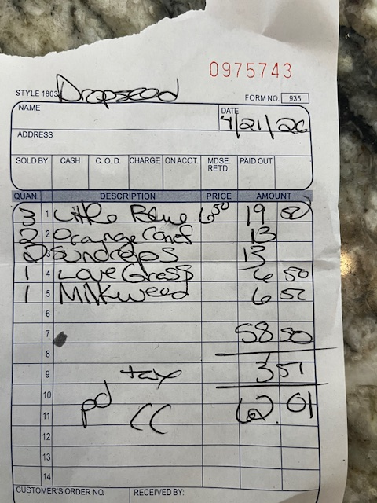

- Take photo of cancelled check or of credit card statement (you can black out other purchases)
Your name must be on them. Name the photo as described above.

- Fill out the Google Form.

- Submit all your photos to our gmail address. This may require 2 or 3 emails if files are large.
Wild.ones.louisville@gmail.com
In the subject header provide: Your Last Name followed by WOL Plant Reimbursement. Example: Carreiro WOL Plant Reimbursement

